**The case study of Karnataka :**

Karnataka’s coastal zone is a complex and dynamic but sensitive ecosystem.  It is one of the world’s most densely inhabited coastal zones with a population density of about 1,500 people per square kilometre. The Western Ghats extend parallel to Karnataka’s coastline. The Ghats are vital since fourteen rivers flow from them into the Arabian Sea, substantially contributing to the diversity of coastal ecosystems by providing nutrient benefits, dissipating sea wave energy, and protecting against tsunamis. These rivers carry silt and organic debris from the forested hinterland into the estuarine areas and the coastal sea and contribute greatly to the productivity and diversity of the coastal ecosystems. Tides travel long distances, even 20-30 kms inland, through many of these rivers, making the saline aquatic habitat suitable for several marine and estuarine organisms. The southwest coast of Karnataka has a rich biodiversity with 184 species of fish fauna, 59 species of mangroves, and nearly 14 species of coral reefs (Zacharia et al., 2008).The coastal waters of India’s southwest coast sustain a diverse marine ecology and are among the most valuable in the world due to coastal upwelling. Karnataka’s coastal zone also comprises 27,000 square kilometres of a continental shelf and 31 operational Special Economic Zones [SEZ] out of 51 (College of Fisheries, 2021; Press Information Bureau [PIB], 2019). As a result, Karnataka facilitates economic expansion in agriculture and horticulture, fishing and aquaculture, shell mining, harbour development, and trade and transportation (Environmental Management & Policy Research Institute, n.d.). Such development impetus naturally affects coastal ecosystems, including mangroves, coral reefs and fisheries. Since 2014, Karnataka has been on a port-development spree under the Karnataka Minor Ports Development Policy. The state is developing one major and 12 minor ports (Government of Karnataka, 2014). The region supports a high degree of economic development such as agricultural and horticultural activities, fishing and aquacultures, sand and shell mining industry, harbour development, trade and transport, etc. which naturally take their toll on sea shoreline, coastal ecosystems, including mangroves and its biodiversity.  Major problems that the coast has been facing i.e.,erosion, migration of river mouths, siltation of ports and harbours.

 The coastal zone of Dakshina Kannada and a part of Udupi districts which are the densely populated zones in India. extends for over 120 km ,from Lat.12 degrees 45 minutes-13 degrees 45 minutes North and long.74 degrees 35 minutes- 74 degrees 55 minutes East. Around 30% of the coastline experiences moderate soil erosion, while 16% faces severe erosion, with Dakshina Kannada and Udupi districts showing the most severe erosion. Erosion along the coastline occurs in three main forms: along open beaches, at the mouths of rivers and estuaries, and at tidal reaches of rivers. The picturesque coastline of Karnataka, stretching along the Arabian Sea, faces a silent but relentless adversary of coastal erosion. This natural process, exacerbated by human activities, has far-reaching consequences across various domains.Coastal erosion is causing the loss of valuable land, especially in the heavily affected Dakshina Kannada and Udupi districts. This results in reduced agricultural land and space for development. Erosion has led to damage to critical infrastructure including roads, buildings, and coastal protective structures. This not only incurs repair costs but also disrupts transportation and connectivity. Villages and towns along the coast, such as those in Dakshina Kannada and Udupi, face the threat of displacement as erosion encroaches upon inhabited areas, forcing people to move and impacting their livelihoods. Coastal ecosystems, including mangroves, estuaries, and beaches, are being degraded. This affects biodiversity, disrupting habitats for various marine and coastal species. The loss of natural barriers due to erosion makes coastal areas more susceptible to flooding and damage from storms. This increased vulnerability poses a risk to both people and property.The tourism industry is particularly affected as erosion degrades beaches and coastal attractions, leading to a potential decline in tourist visits. Additionally, fisheries can be impacted by changes in coastal and marine environments, affecting the livelihoods of local fishermen. Saltwater intrusion into agricultural lands due to erosion and the breaching of natural barriers can reduce soil fertility and crop yields, adversely affecting local farming communities. Building infrastructure such as roads, buildings, and ports disturbs the natural coastal landscapes and lead to increased erosion. Removing vegetation for development decreases the natural barriers that protect shorelines from erosion. Extracting sand for construction and other uses directly removes material from beaches and coastal systems, accelerating erosion. Human-induced climate change is causing sea levels to rise, which increases the rate of coastal erosion. Developments of major/minor ports and fishery harbours consist of the construction of coastal structures like break waters, jetties, groynes and reclamation bunds. Improvements of the ports also involve the dredging and disposal activities to maintain these essential depths for navigation. These coastal structures and the dredging activities interfere in the coastal processes of the region. Alterations in the coastal processes have a large impact on the coast line (Kudale, 2010).

**Honnavar port :**

Honnavar port is located on 10 km long Kasargod stabilised spit pointing northwards at the mouth of Sharavati River. The port is near to the town of Honnavar in Uttara Kannada district. Honnavar shows (Figure 7) the rate of erosion is -1.2875m/y and rate of accretion is +0.7967m/y during the period 1973 to 2014. It is a major fishing harbour. Pavinakurve spit(a narrow, elongated landform that extends from the coastline into the sea)located to the northern side of the river mouth near Honnavar port is affected by erosion, which means that it is experiencing loss of material over time. The dynamics of spits and their interaction with coastal processes play a crucial role in shaping the shoreline and coastal ecosystems. Kasarkode spit which is situated on the southern bank of Sharavathi River shows accretion. The shoreline recession is observed at about -52.5720m and +32.5733m progradation is recorded for the period of 1973-2014.  The spit growth across river mouths is narrowing river mouth.

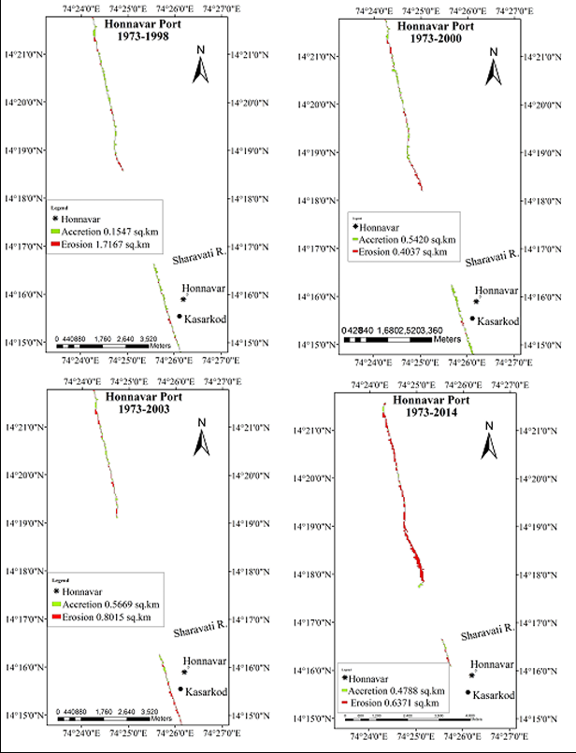

***Figure 2*** :Erosion and Accretion at Honnavar

**The Old Mangalore Port (Kotepura-Bengre)**

The Old Mangalore Port is located to the south of New Mangalore Port. It is popularly known by the name of Bunder. The port was used to ferry goods and passengers to Lakshadweep Island and Middle East countries. Now fishing has become the main activity of this harbour. Old Mangalore port has the rate of accretion is +1.2900m/yr and rate of erosion is not recordable during the period  of 1973 to 2014. Net accretion during this period is +52.6550m. The study area covers geomorphological classes such as rocky cliffs, alluvial plain, sand beaches, sand spits and manmade feat. The Netravati estuary contributed a major amount of sediments for the growth of spits. Breakwaters are built at port entrances to maintain water depth.Sediment continuously accumulated, reducing the depth of the navigation channels. This resulted in frequent fishing boat capsizing and casualties.To prevent further sediment accumulation, southern and northern breakwaters were constructed in 1991 and 1993 respectively.Dredging was carried out in 1994-95 to achieve the required depth for navigation.The breakwaters and dredging successfully increased the navigation channel depth to 4 metres, eliminating boat capsizing incidents since 1995.Bengre beach was vulnerable to erosion in the late 1970s and early 1980s. After building an experimental seawall in 1984-85, the beach stabilised and began to grow, blocking littoral drift. In the early 1990s, breakwater construction caused sediment to accumulate and expand the shoreline at Bengre. However, erosion increased at Kotepura beach. By May 1994, after a new breakwater was built, the Bengre shoreline advanced about 100 metres within a year, with 0.44 million cubic metres of sediment covering 19 hectares. Most of this sediment (0.35 million cubic metres) accumulated in 1994-95, much higher than previous rates.

**The New Mangalore Port**

Depth contours of New Mangalore Port area show shoreline changes and erosion/accretion patterns in the nearshore region due to construction of breakwaters. During pre- and post-monsoon periods of 1965, the nearshore region, north of were found to be river discharge, littoral drift and sediment the approach channel was steeper than on the southern sideThe construction of 570-metre-long breakwaters in the late 1960s and their extension by 200 metres in 1977 at New Mangalore Port led to significant shoreline changes and sediment buildup. After these constructions (Figures 7a, 7b, and 7c), the northern side saw more sediment accumulation and a larger shoreline shift (100-150 metres) compared to the southern side (60-100 metres).

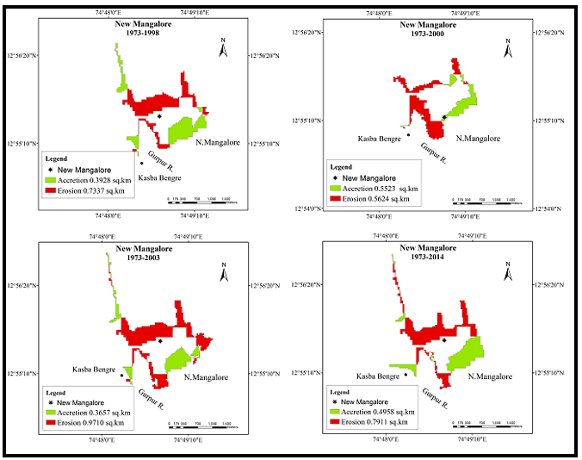

This was partly due to the dumping of 2.4 million cubic metres of dredged material.Over 32 years (1965-1997), the northern nearshore region's slope became gentler, while the southern side's slope became steeper (Figure 7e). The beach north of the northern breakwater widened and had gentler profiles, whereas the beach south of the southern breakwater narrowed. These changes were influenced by river discharge, littoral drift, and sediment movement.

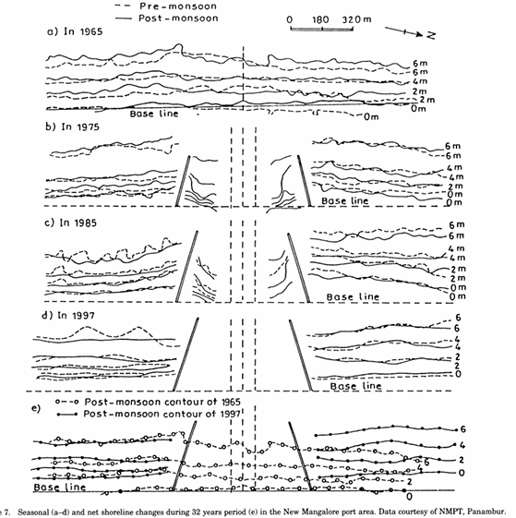

Coastal erosion poses a formidable challenge to communities worldwide, and in small island developing states (SIDS) like Karnataka, it’s a pressing concern. Human interference includes mainly construction of coastal structures and sand mining.As land disappears and infrastructure faces damage, stakeholders often turn to seawalls as a customary defence mechanism.Seawall construction began in 1978-79, and over a 20 kilometre stretch of coastline, seawalls have been built. As severe storms hit the coast of Karnataka and destroyed shelters and homes of coastal communities, the state turned to the construction of seawalls and groynes for protection. Currently, more than 20 seawalls cover nearly 15% of Karnataka’s coast. Despite preventing soil erosion, seawalls disturb longshore drift and cause down shore erosion, redirect water flow, and create water pressure in a narrow opening. These river mouths then become spots for higher erosion (Vinayaraj et al., 2011). Moreover, shoreline hardening affects the functioning and habitat of ecosystems. Structures like seawalls support 23% less biodiversity and nearly 45% lesser organisms (Gittman et al., 2016). Moreover, while seawalls provide protection to coastal settlements, they also forcibly change livelihood patterns. They disconnect coastal communities from the shores and alter their use and reliance on marine ecosystem reserves. Therefore, though seawalls provide momentary relief and protection, their long term efficiency is questionable.

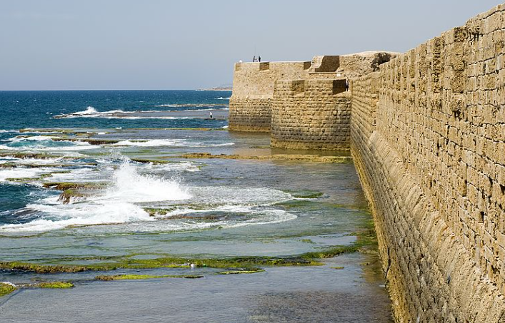

 Moreover, to facilitate its vision of infrastructure development, Karnataka’s new industrial policy has made it easier to acquire land. It has removed restrictions on land conversion and exempted industries from the Karnataka Land Reforms Act 1961, targeting national and international investors for port development and management. Privatisation of ports and harbours risks resource exploitation and regulatory non-com pliance, which can further contribute to deterioration of the region’s resources. Multiple port projects in Karnataka have already run into trouble from coastal communities resisting development to protect their livelihoods and local biodiversity.

Mangroves are a unique habitat and are largely inspired by sea level changes and wave energy.These are specialised ecosystems consisting of diverse groups of tropical trees and shrubs adapted to grow in intertidal regions. In coastal Karnataka, mangroves serve as vital ecosystems, providing ecological, economic, and protective benefits, 59 species of foraminifera belonging to 32 genera, 24 families, and five suborders were identified from the cores of Chithrapu and Kumbla of Karnataka sites.The construction of ports in Karnataka significantly impacts biodiversity within mangrove ecosystems. Habitat loss, fragmentation, and alteration of ecological processes disrupt the delicate balance of these habitats, leading to declines in species abundance and diversity. Displacement of species, loss of nursery areas, and changes in community structure further contribute to biodiversity loss. Addressing these impacts requires conservation measures that prioritise the protection and restoration of mangrove habitats to ensure the long-term viability of diverse marine and terrestrial species in coastal areas. Avicennia marina (Grey Mangrove) is commonly found in Karnataka's mangrove forests and provides habitat for various organisms. The destruction of mangroves  reduces suitable habitat for Grey Mangroves, leading to declines in populations of associated species such as mudskippers (Periophthalmus spp.) and fiddler crabs (Uca spp.). Red Mangroves are another important mangrove species in Karnataka's coastal areas. Their removal for port development reduces habitat availability for species like the Indian mudskipper (Periophthalmus septemradiatus) and the Malabar giant squirrel (Ratufa indica), which use mangroves for foraging and nesting.Mangrove crabs, such as the purple mud crab (Scylla serrata) and the Indian mangrove crab (Scylla tranquebarica), are integral components of mangrove ecosystems in Karnataka Habitat destruction due to port construction threatens these species, disrupting the food web and impacting predators such as estuarine crocodiles (Crocodylus porosus) and water monitors (Varanus salvator). Many fish species rely on mangroves for spawning grounds and nursery habitats. Construction activities can disrupt these critical life stages, impacting populations of economically important species such as the spotted scat (Scatophagus argus), the milkfish (Chanos chanos), and the giant tiger prawn (Penaeus monodon). Mangroves support diverse bird species, including waterbirds, shorebirds, and raptors. The loss of mangrove habitat to port development affects nesting sites and foraging areas for species such as the white-bellied sea eagle (Haliaeetus leucogaster), the Western reef heron (Egretta gularis), and the Indian pitta (Pitta brachyura).

Mangroves play a crucial role in coastal ecosystem ,by giving protection against coastal erosion and natural diasasters while providing habitats and food for a wide range of species, including fish,mammals,and birds.In Karnataka mangroves cover an area of 10.04 square kilometers,primarily in Uttara kannada and Udupi districts,Coastal regions of Karnataka has recorded 14 species of mangroves belonging to 8 families The dominant species include Rhizophora mucronate,Acanthus ilicifolius,Acrostichum aureum,Aegiceras corniculatum,Avicennia marina,Avicennia officinalis,Bruguiera cylindrica.(EVSA-K2) Hosting 14 species from 8 different families one significant species Rhizophora mucronate is particularly vulnerable to the impacts of port construction such as the development of the honnavar port the environmental consequences of such constructions are severe leading to habitat loss ecosystem distruption and increased pollution the destruction of mangrove growth and releasing pollutants that harm mangrove health. Economically, the impact is also substantial as the loss of mangroves results in decreased fish populations,which adversely affects local fisheries and the livelihoods dependent on them.Additionally,the degradation of mangrove ecosystems leads to decline in eco-tourism,further impacting the local economy.Thus, the construction of ports in mangrove areas poses significant environmental and economic challenges,highlighting the need for sustainable development practices that preserve these vital coastal ecosystems.